
Critical Laboratory Trends: Potassium, Sodium & Key Clinical Markers
Electrolyte Trends: Potassium (K) & Sodium (Na)
Date | Potassium (K) (mmol/L) | Status (Ref: 3.50–5.10) | Sodium (Na) (mmol/L) | Status (Ref: 133–145)
Jan 2023 | 5.03 | Borderline high | 141.8 | Normal
Jul 2023 | 4.62 | Normal | 140.5 | Normal
Sep 2023 | 4.65 | Normal | 143.0 | Normal
Oct 2023 | — | — | — | —
Dec 2023 | 5.08 | Borderline high | 141.3 | Normal
Apr 2024 | 4.60 | Normal | 137.3 | Normal
Jun 2024 | 4.51 | Normal | 140.1 | Normal
Sep 2024 | 4.54 | Normal | 142.0 | Normal
Dec 2024 | 4.46 | Normal | 138.8 | Normal
Apr 2025 | 4.61 | Normal | 140.7 | Normal
Jul 2025 | 4.94 | Normal | 143.2 | Normal

- Potassium (K): Remained within or just above reference, with mild elevations at the start (Jan/Dec 2023), then stable.
- Sodium (Na): Consistently within reference, minor fluctuations, no clinical concern.
Trends are visualized below.
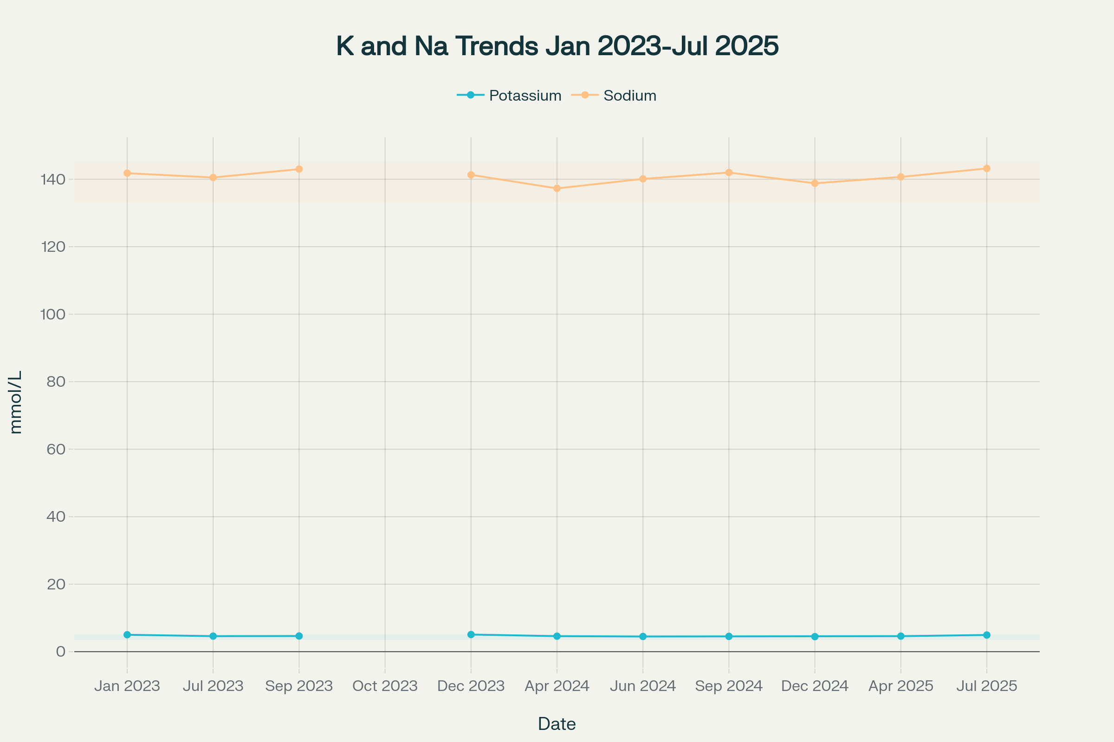
Trends of Potassium and Sodium levels over time with reference ranges
Combined Trends: Hemoglobin, Hematocrit, and RBC
Date | Hemoglobin (g/dL) | Hematocrit (%) | RBC (M/μl)
Jan 2023 | 12.8 | 39.3 | 5.67
Jul 2023 | 12.1 | 35.2 | 5.40
Sep 2023 | 12.6 | 37.3 | 5.71
Oct 2023 | 13.3 | 39.3 | 6.05
Dec 2023 | 12.9 | 40.4 | 5.95
Apr 2024 | 12.8 | 39.1 | 5.84
Jun 2024 | 12.3 | 37.4 | 5.59
Sep 2024 | 13.2 | 40.2 | 6.00
Dec 2024 | 13.2 | 41.0 | 6.17
Apr 2025 | 13.1 | 40.6 | 6.04
Jul 2025 | 12.8 | 39.0 | 6.04

- Key trend: Mild, chronic microcytic anemia pattern with lowest values mid-2023/mid-2024, then recovery and stabilization.
Liver Function & Bilirubin Trends
Date | Total Bilirubin (mg/dL) | AST (U/L) | ALT (U/L)
Jan 2023 | — | 25.7 | 37.3
Jul 2023 | 3.02 | 20.7 | 22.2
Sep 2023 | 2.13 | 18.3 | 25.5
Oct 2023 | 2.01 | — | —
Dec 2023 | 2.67 | 32.9 | 26.1
Apr 2024 | 2.58 | 24.5 | 29.0
Jun 2024 | 2.06 | 24.2 | 26.2
Sep 2024 | 1.83 | 19.8 | 31.6
Dec 2024 | 3.39 | 21.7 | 26.3
Apr 2025 | 2.06 | 15.2 | 20.9
Jul 2025 | 2.83 | 13.8 | 18.3

- Bilirubin: Persistently elevated, peaking Dec 2024/Jul 2025.
- Transaminases: Mild fluctuations, trending downward, no persistent elevation.
Iron Status and Ferritin
Date | Ferritin (ng/mL) | RBC (M/μl) | Hemoglobin (g/dL)
Oct 2023 | 262.80 | 6.05 | 13.3
Dec 2023 | — | 5.95 | 12.9
Apr 2024 | 258.20 | 5.84 | 12.8
Sep 2024 | 289.60 | 6.00 | 13.2
Apr 2025 | — | 6.04 | 13.1
Jul 2025 | 229.20 | 6.04 | 12.8

- Ferritin: Always within/above reference, iron stores adequate.
- Combined with RBC/HGB: Confirms anemia is not due to iron deficiency.
Combined Monitoring: Potassium, Sodium, and Renal Function
Date | Potassium (K) | Sodium (Na) | Creatinine (mg/dL) | Urea (mg/dL)
Jan 2023 | 5.03 | 141.8 | 0.9 | 27.5
Jul 2023 | 4.62 | 140.5 | 0.9 | 26.8
Sep 2023 | 4.65 | 143.0 | 0.9 | 29.3
Dec 2023 | 5.08 | 141.3 | 0.8 | 31.3
Apr 2024 | 4.60 | 137.3 | 0.8 | 26.7
Jun 2024 | 4.51 | 140.1 | 0.9 | 29.0
Sep 2024 | 4.54 | 142.0 | 0.9 | 39.2
Dec 2024 | 4.46 | 138.8 | 0.9 | 26.9
Apr 2025 | 4.61 | 140.7 | 0.9 | 22.1
Jul 2025 | 4.94 | 143.2 | 0.9 | 27.1

- Interpretation: Electrolytes and renal function are stable, with no evidence of acute kidney injury or electrolyte imbalance.
Key Combined Trends to Monitor
- Potassium + Creatinine: Both stable, no evidence of hyperkalemia due to renal dysfunction.
- Hemoglobin + Ferritin: Chronic microcytic anemia with adequate iron stores—suggests non-nutritional cause.
- Bilirubin + Liver Enzymes: Persistent mild hyperbilirubinemia with normalizing transaminases—suggests benign etiology (e.g., Gilbert’s syndrome).
- Sodium + Urea/Creatinine: No hyponatremia or renal impairment.
Interpretation Highlights
- Electrolyte stability: Both K and Na are within reference, with minor, clinically insignificant fluctuations.
- Chronic microcytic, hypochromic anemia: Stable, non-progressive, not due to iron deficiency.
- Bilirubin: Persistently elevated, but with no signs of hemolysis or liver dysfunction.
- Renal and glycemic control: Excellent throughout.
- No evidence of acute or chronic systemic disease.
- Combined trend monitoring: No critical interactions or combined abnormalities detected.
This structured, multi-year dataset supports ongoing monitoring and confirms the absence of acute or progressive pathology in the most critical laboratory parameters.
⁂

